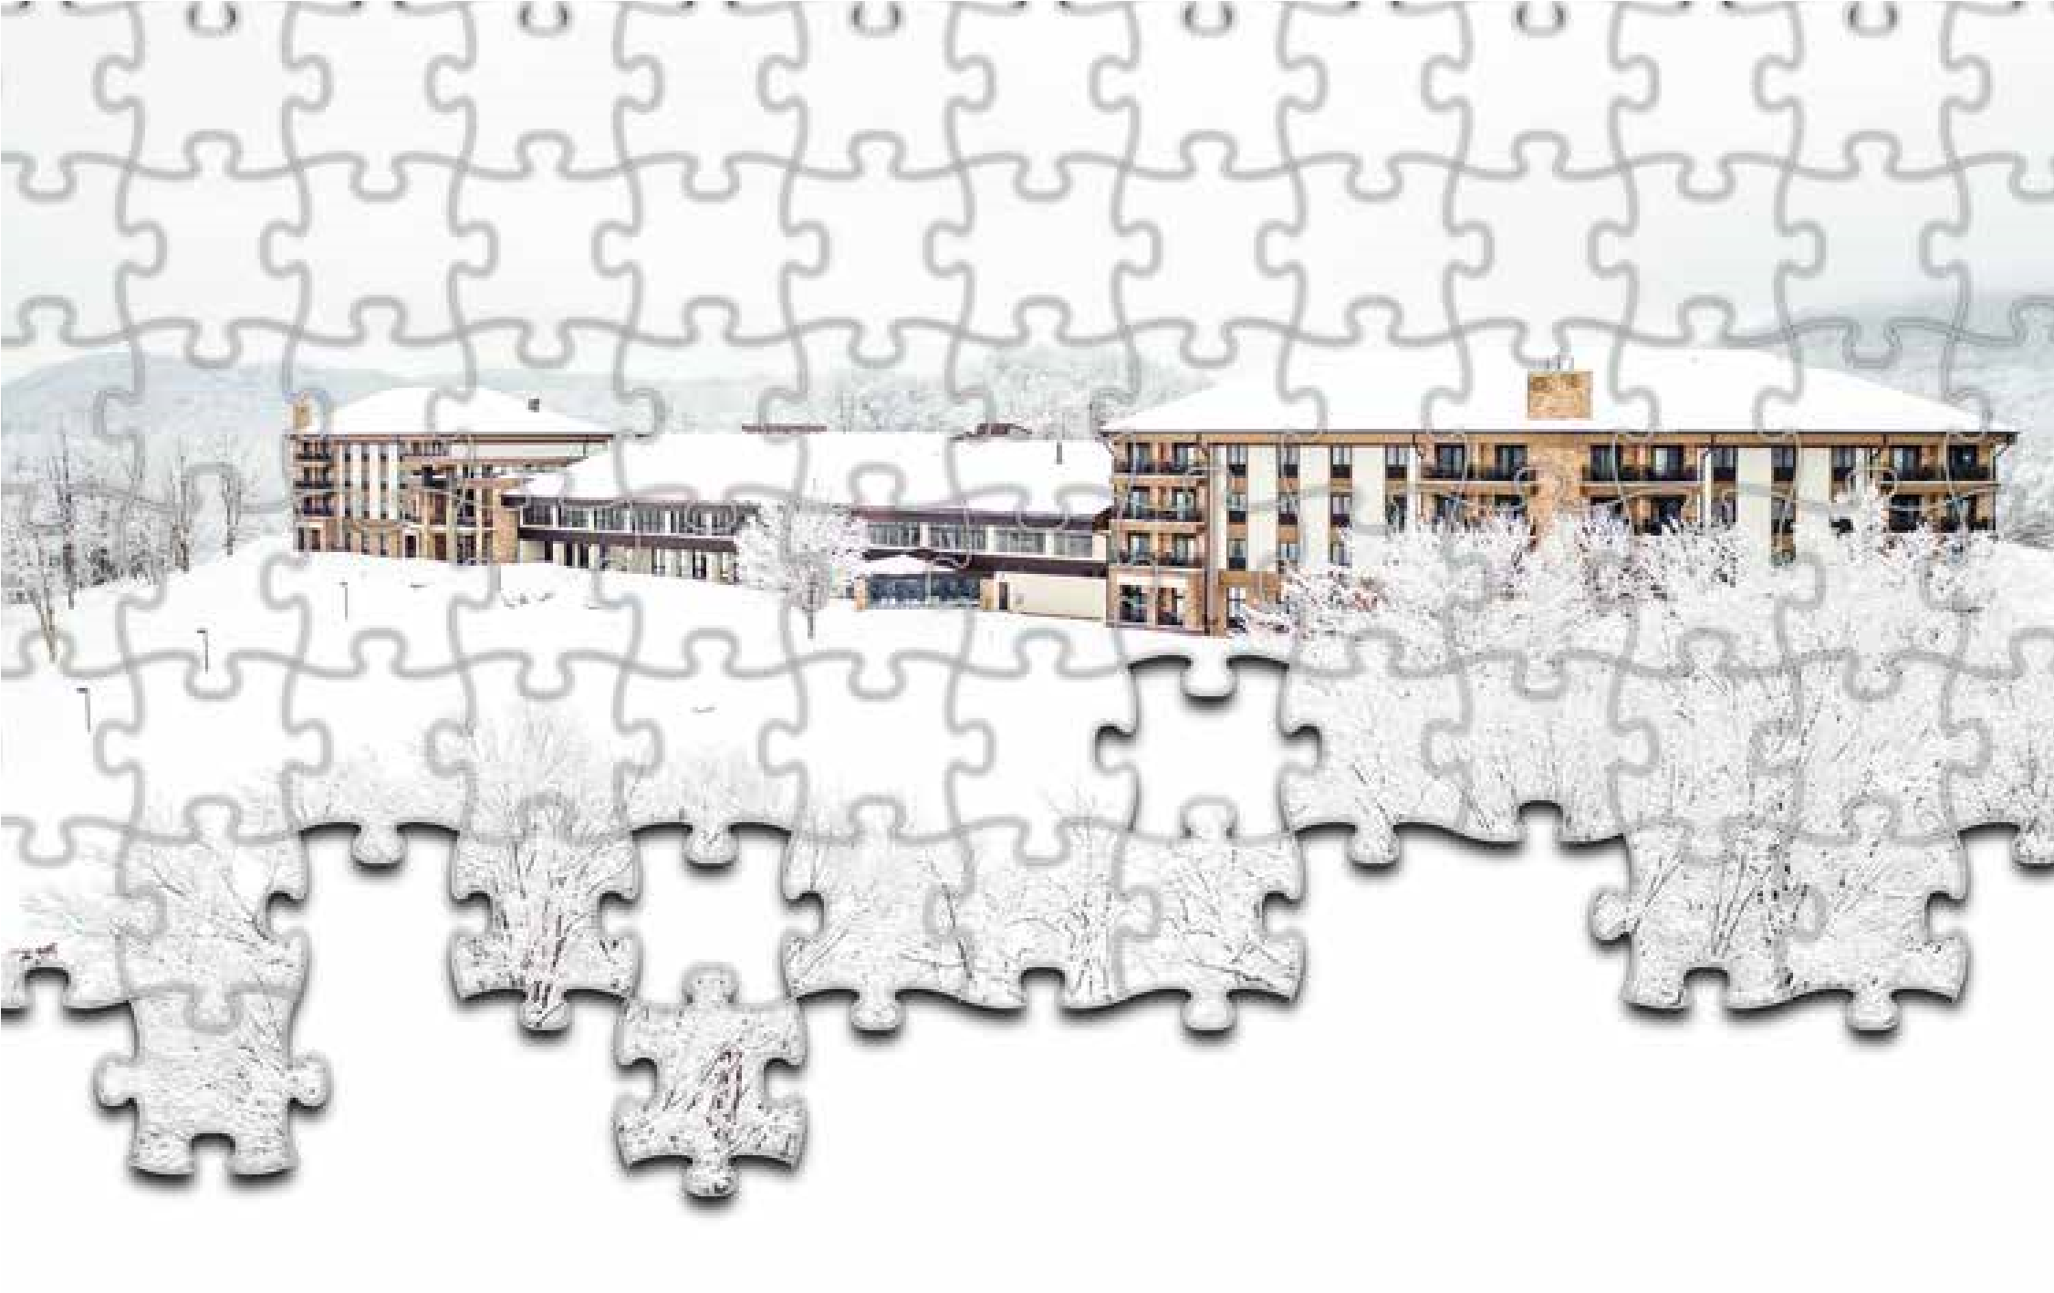
Rochesterfest
Jigsaw Puzzle Contest
Saturday June 25th, 2024
9:30 pm Registration Contest at 10:00
» For more information call: 507-512-0857

Jigsaw Puzzle Contest
June 25, 2024 10:00:00 a.m.
Soldiers Field
Registration Form (required for all participants)
Team Name:
Team Captain: Phone/Cell: ___________________
Address: ________________________ City: __________________ State: ____ Zip: _______
Email: ________________ _______________
Team Members: _______________________
_______________________
_______________________
_______________________

$30 per team Amount Due: _____________
Please mail this completed form along with payment to:
Rochesterfest
Jigsaw Puzzle Contest
P.O. Box 007
Rochester, MN 55903

